Title of the abstract
Hanako Yokohama¹, Taro Yamada^{2,*} and Taisto Tutkija^{1,2}
1 Suzuki Laboratory, University of Tokyo, Tokyo, Japan
2 physical chemistry Department, National University of Yokohama, Kanagawa, Japan
*Contact: Hanako.yamada@yokohama.ac.jp

Keywords: photovoltaic, perovskite, impedance spectroscopy
The text is based on Arial font type using size 12 pt. The authors are supposed to keep the style definitions or layout of the template. MAXIMUM LENGTH for the abstract is ONE PAGE.
Start your abstract with a short introduction with possibly some references to relevant publications [1–3]. You can include an illustrative figure or a table. The use of black/white or clear grayscale/raster techniques in formatting the figures is preferred.
Please add one to four keywords of the subject before the text section. These will be used for index purposes. Please limit keywords to one line.
Simple Picture- of Metafile-formats can be used for embedded figure objects. Bitmaps can be used, too, but if possible, file size should be limited to less than 1 Mb.
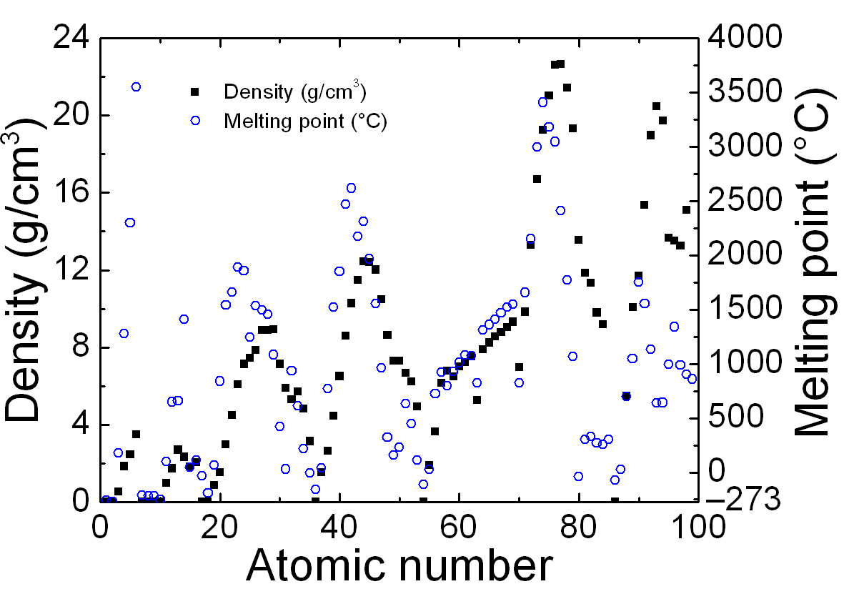
Figure 1: Example plot of some data. Remember to write physical quantity and unit to all axis.
Table 1: Small sample table
 | Header1 | Header2 | Header3
Row1 | 3.0 | 5.945 | 45 %
Row2 | 3.5 | 5.946 | -
Row3 | 3.9 | 3.947 | 48 %
More data | 4.8 | 5.879 | 81 %

1. K. Matsumto, J. Juonio, Article title, Optics Publication 12, 123–456 (1978).
2. O. P. Guru, E. Stein, Book name, Some Publisher Press (1996).
3. Article or page name, available at www.opticslab.unicity/research/thesubject.html, cited on 2016-01-15

